**Insights Writing for the IMDB Dataset Analysis**

**Advanced SQL Project**

**Introduction**

The dataset consists of multiple tables related to movies, actors, ratings, and production details. The structure includes information about movie titles, genres, release dates, production companies, ratings, votes, and personnel involved in filmmaking. The objective of this report is to analyze various aspects of the dataset through SQL queries and derive meaningful insights.

**Queries**

**1.Count the total number of records in each table of the database.**

**Query Explanation:** This query uses the COUNT(*) function to count the number of rows in each table. It helps determine the size of each dataset component.

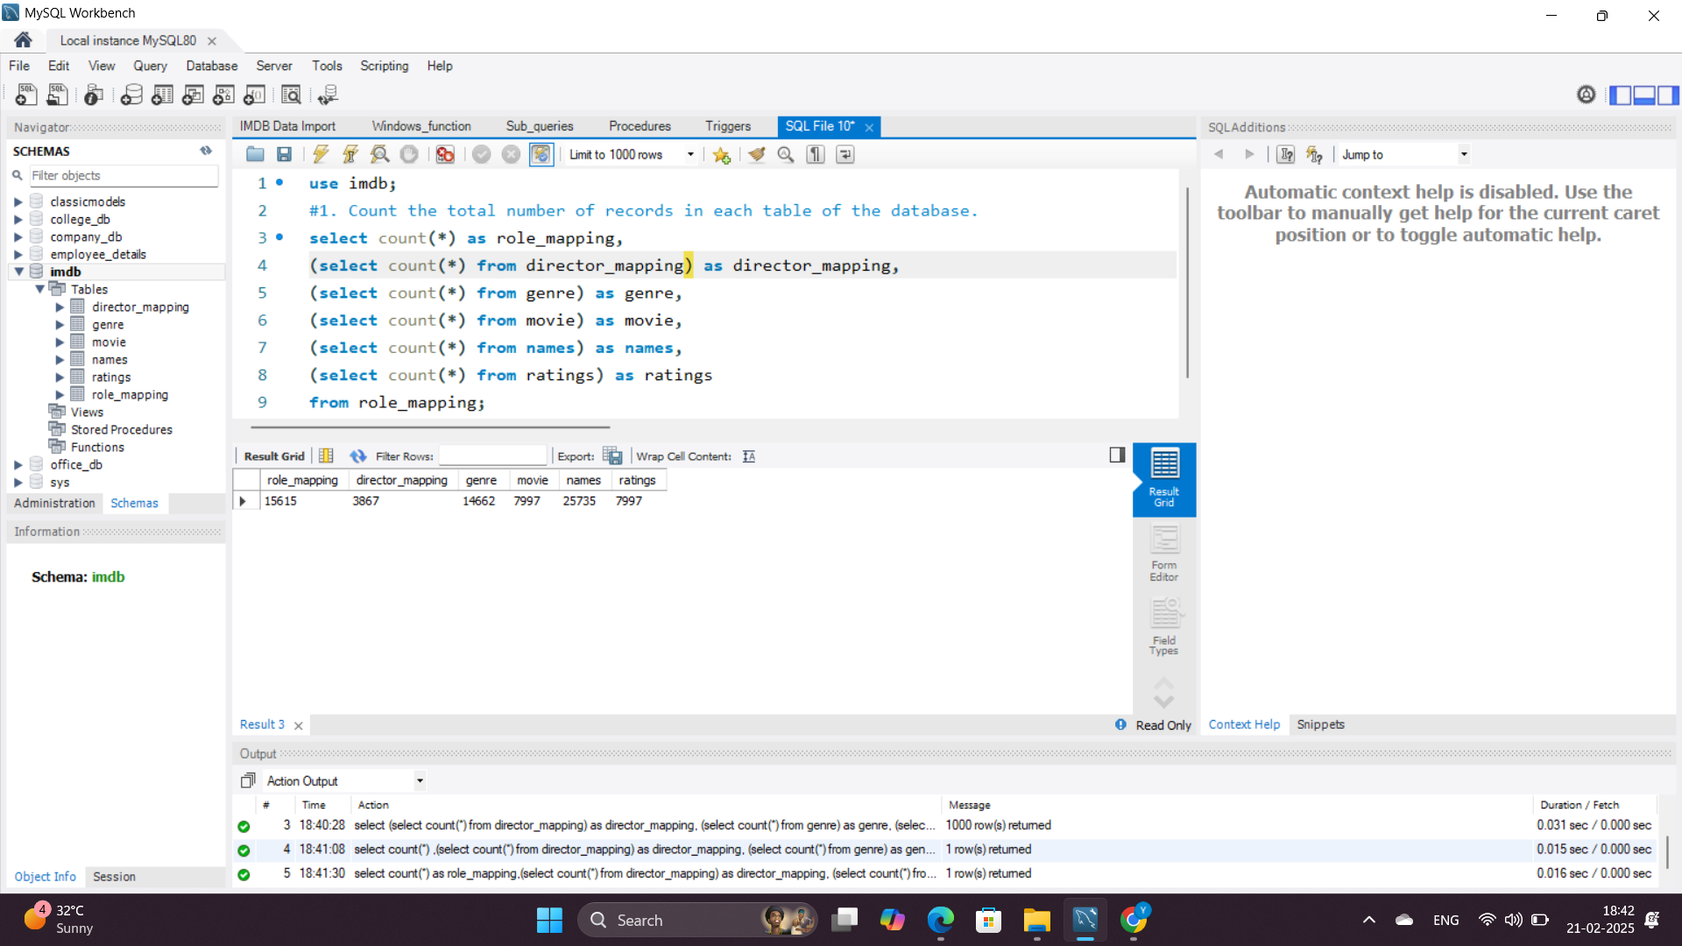**Rationale:** This helps understand the volume of data in each table and assess completeness.

**2. Identify which columns in the movie table contain null values.**

**Query Explanation:** This query dynamically generates and executes SQL statements to check which columns in the movie table contain NULL values.

* INFORMATION_SCHEMA.COLUMNS is queried to get the column names of the movie table.
* GROUP_CONCAT is used to concatenate multiple SELECT statements into one, checking each column for NULL values.
* The result is stored in the @sql variable.
* PREPARE, EXECUTE, and DEALLOCATE are used for dynamic SQL execution.

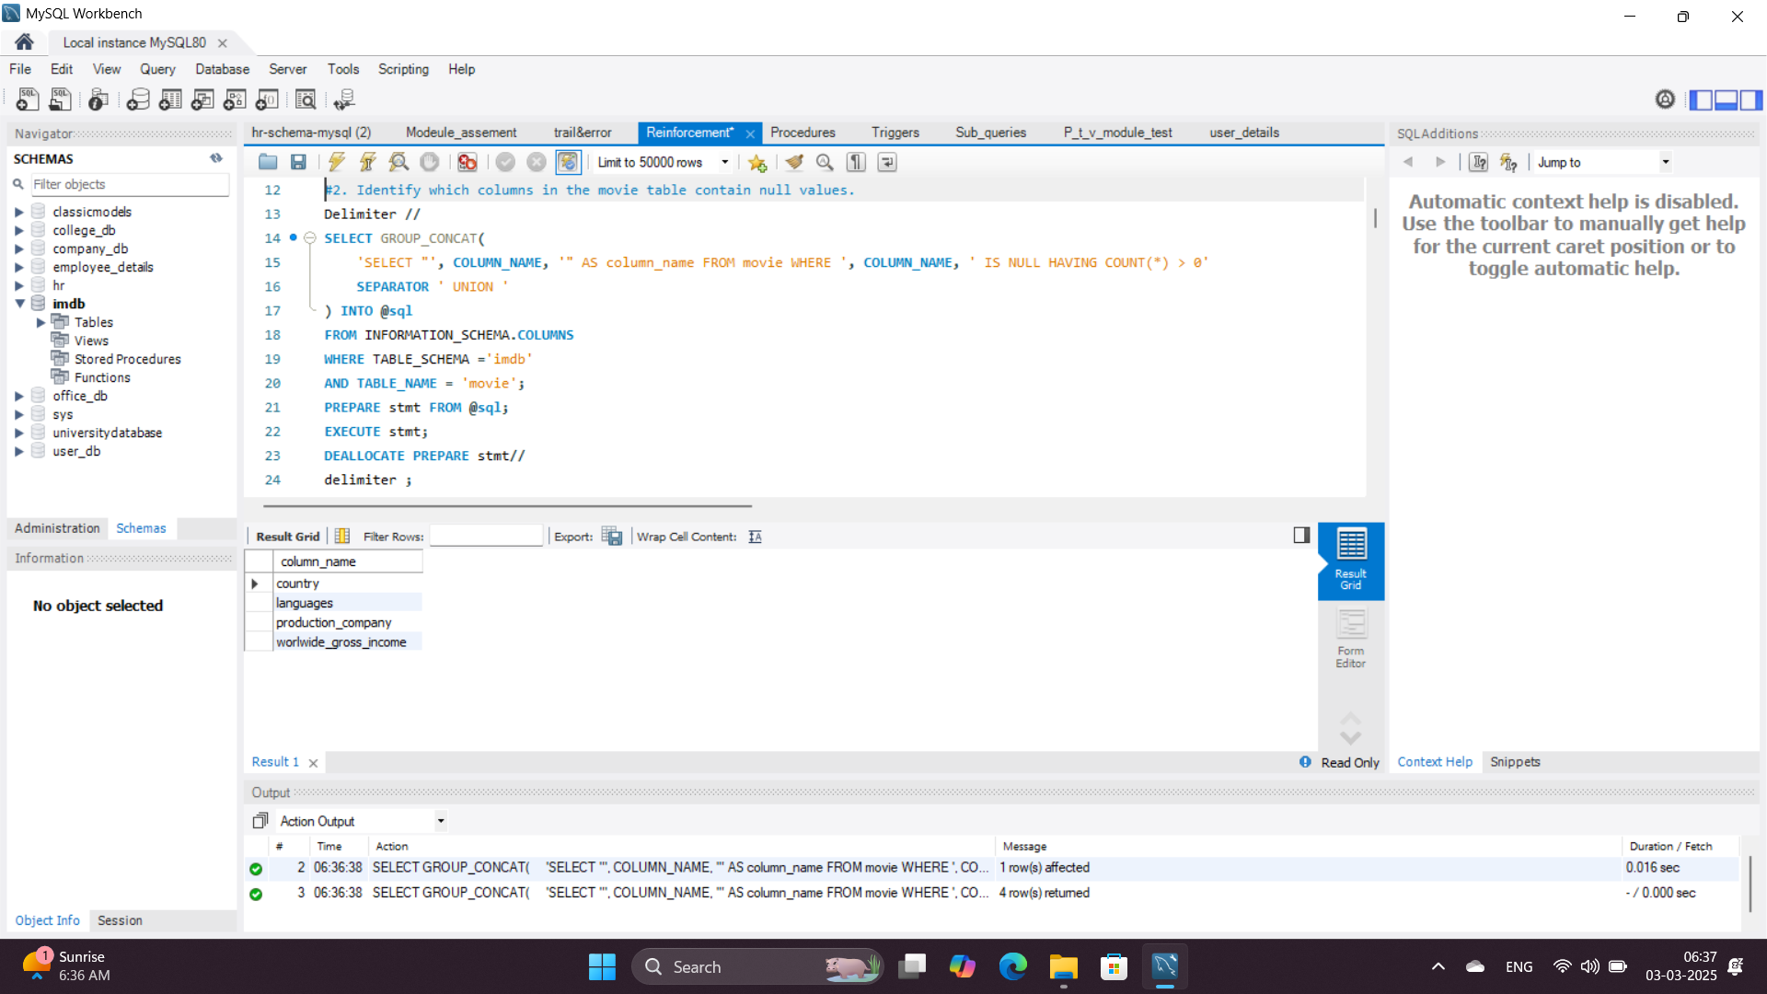**Rationale:** This helps automate the detection of NULL values across all columns without manually checking each one, making the process efficient for large datasets.

**3. Determine the total number of movies released each year, and analyze how the trend changes month-wise.**

**Query Explanation:** This query calculates the number of movies released in each month for every year. It utilizes the SUM(CASE WHEN ... THEN 1 ELSE 0 END) structure to count movies separately for each month.

* The YEAR(date_published) extracts the release year from the date column.
* The MONTH(date_published) = X condition filters movies for a specific month.
* The SUM() function counts the number of movies released in each month.
* The COUNT(id) function provides the total number of movies released each year.
* The GROUP BY release_year ensures that counts are grouped by year.
* The ORDER BY release_year arranges the result chronologically.

**Rationale:** Helps in understanding movie production trends over time by showing the distribution of movie releases across different months within each year.

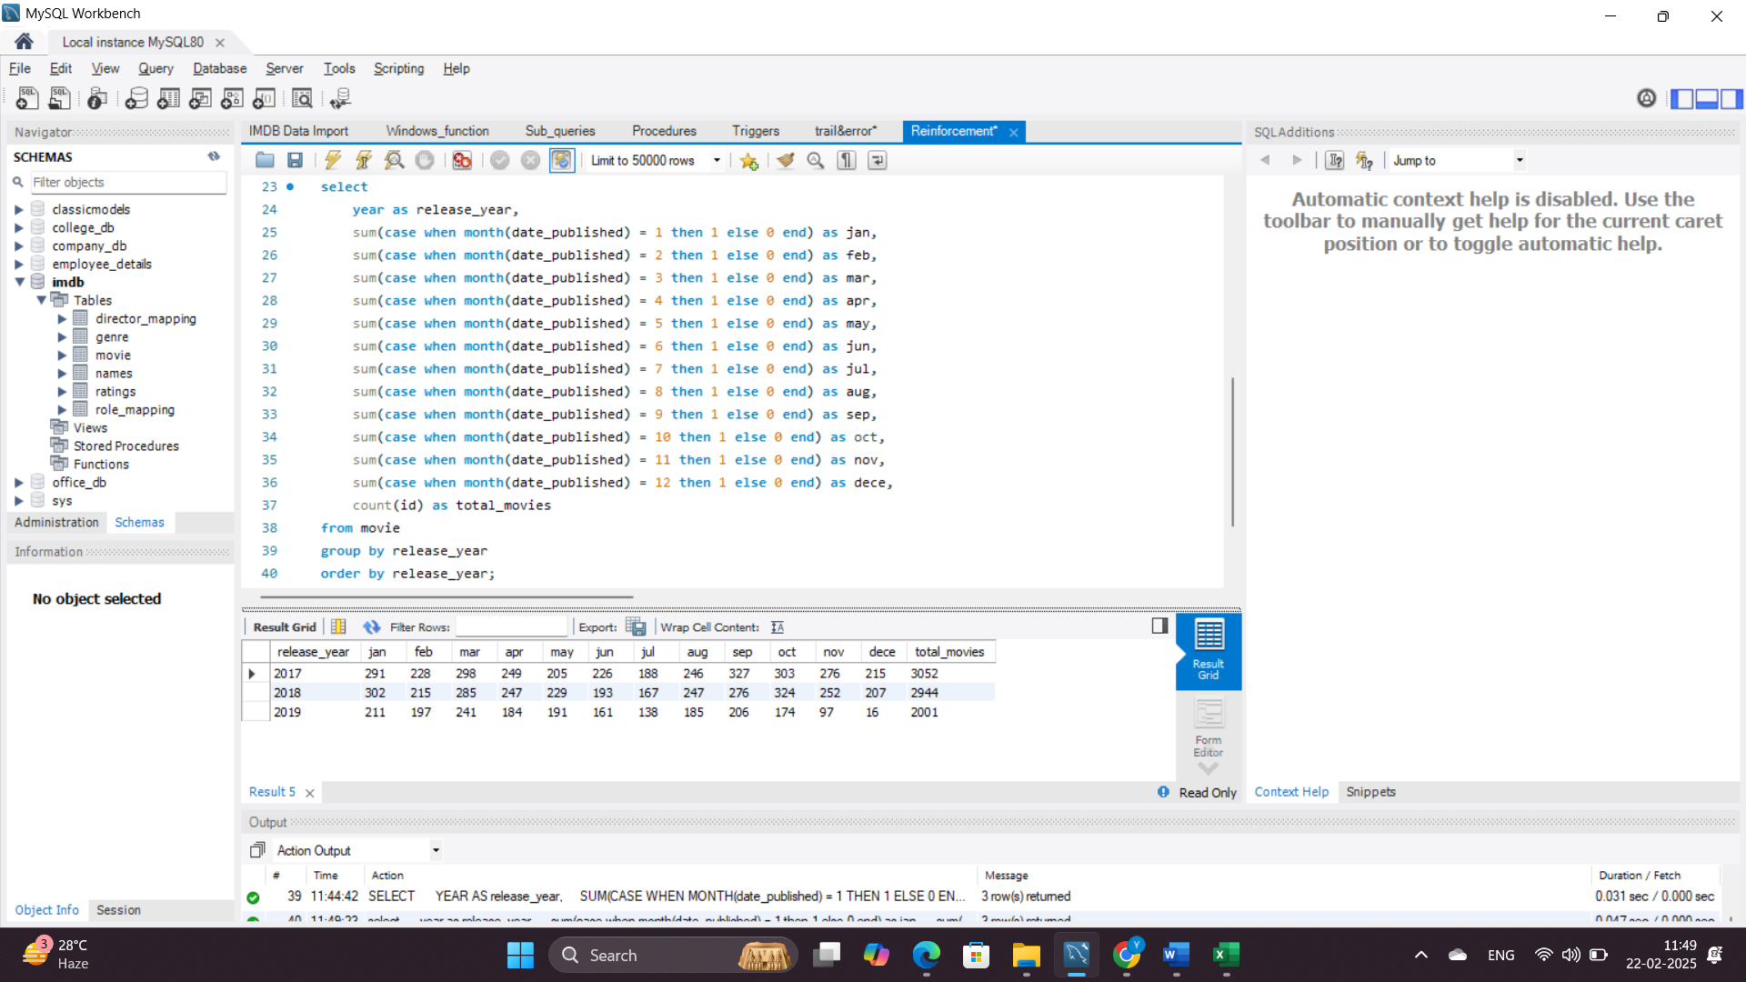

**4. How many movies were produced in either the USA or India in the year 2019?**

**Query Explanation:** The WHERE clause filters for movies produced in the USA or India in 2019.

**Rationale:** Provides insights into country-wise production volume for a specific year.

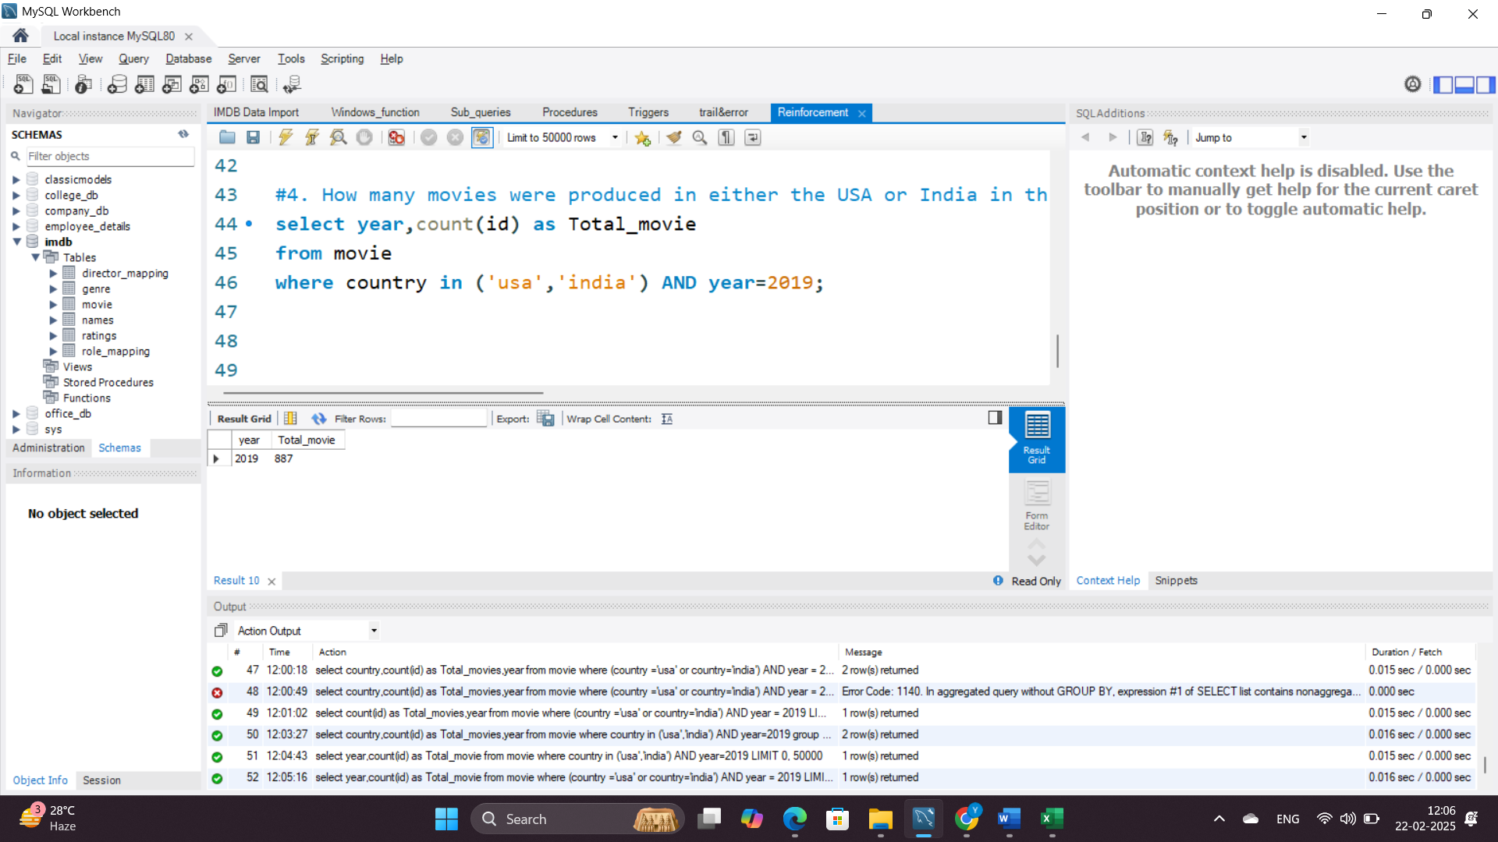

**5. List the unique genres in the dataset, and count how many movies belong exclusively to one genre.**

**Query Explanation:**

* The first query retrieves distinct genres from the genre table.
* The second query finds movies that belong to only one genre:
  + The subquery groups movies by movie_id and filters those appearing in only one genre using HAVING COUNT(genre) = 1.
  + The main query joins this result with the genre table to count how many movies exist for each unique genre.

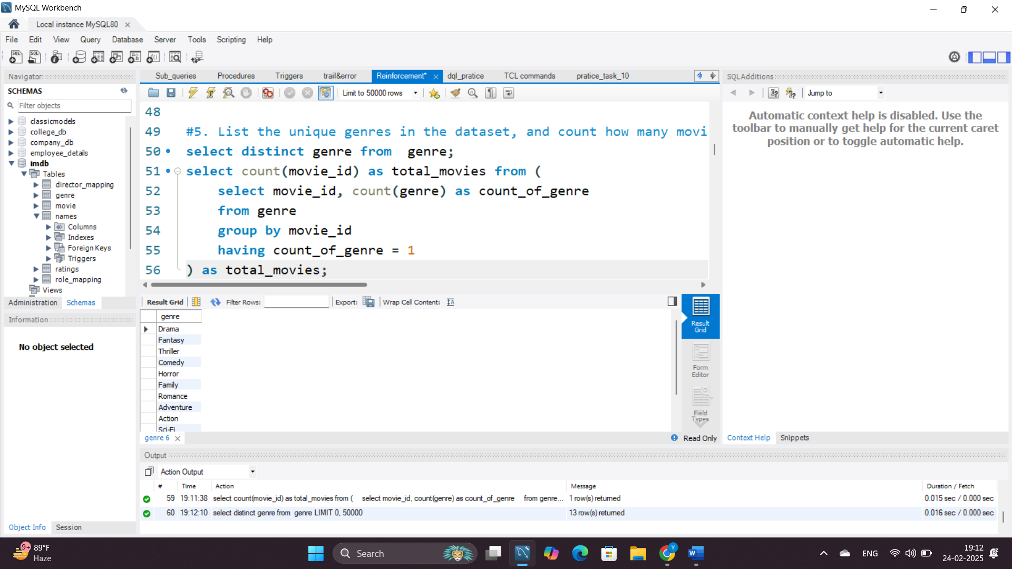**Rationale:** This helps analyze the diversity of movie genres and identifies movies that are strictly categorized under one genre.

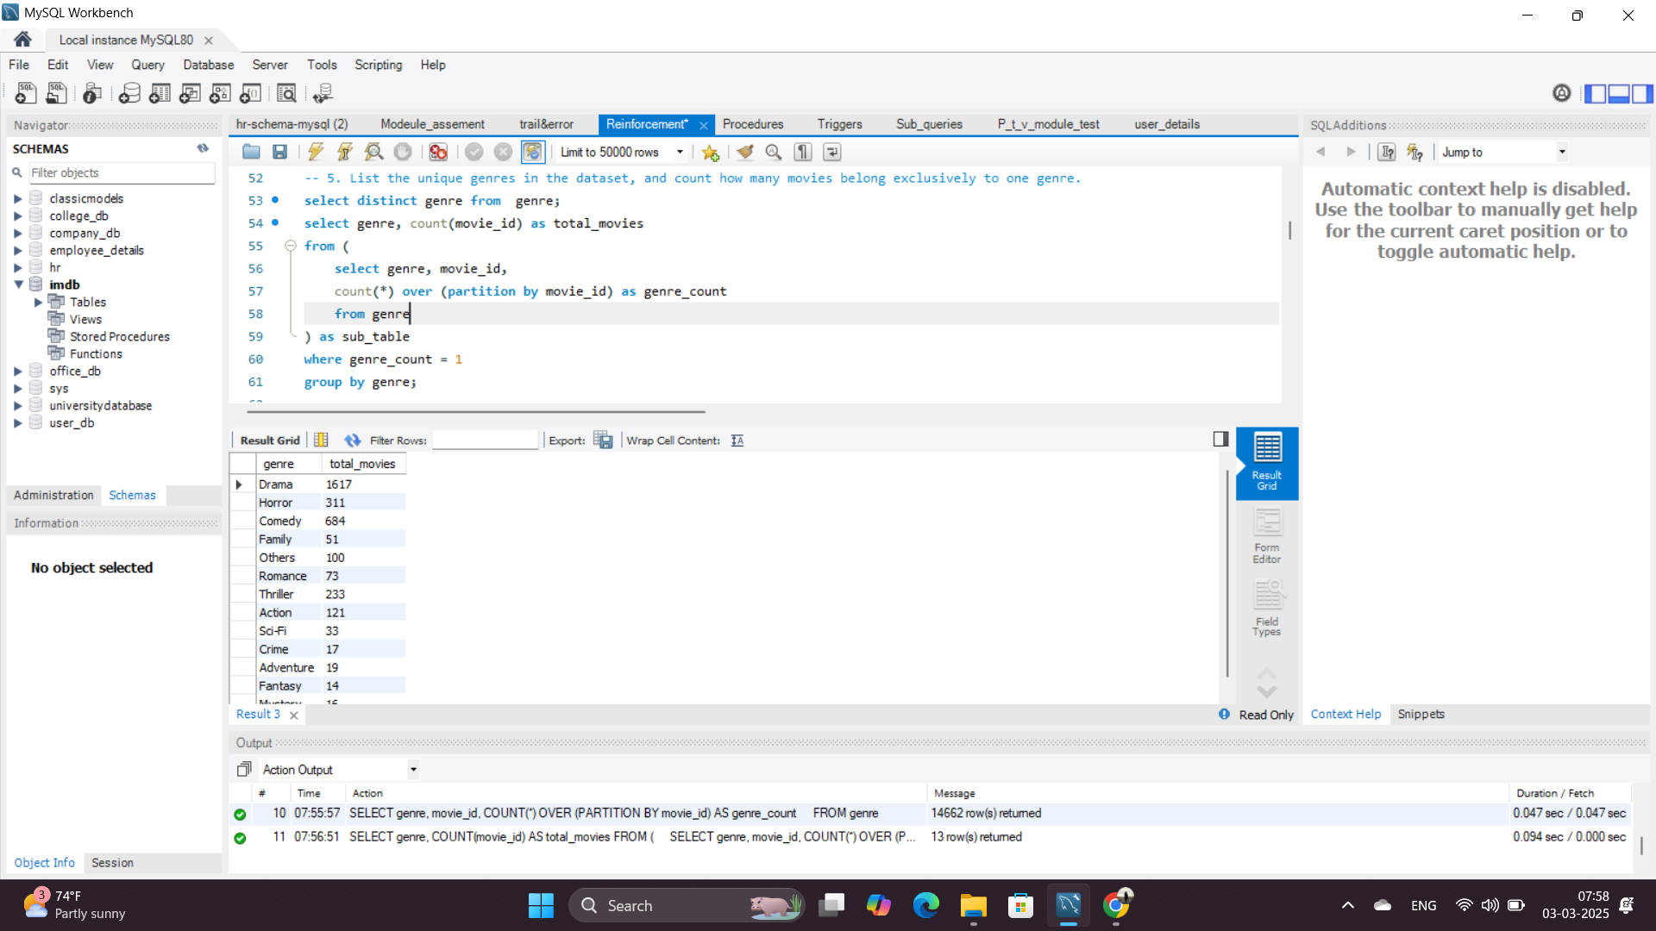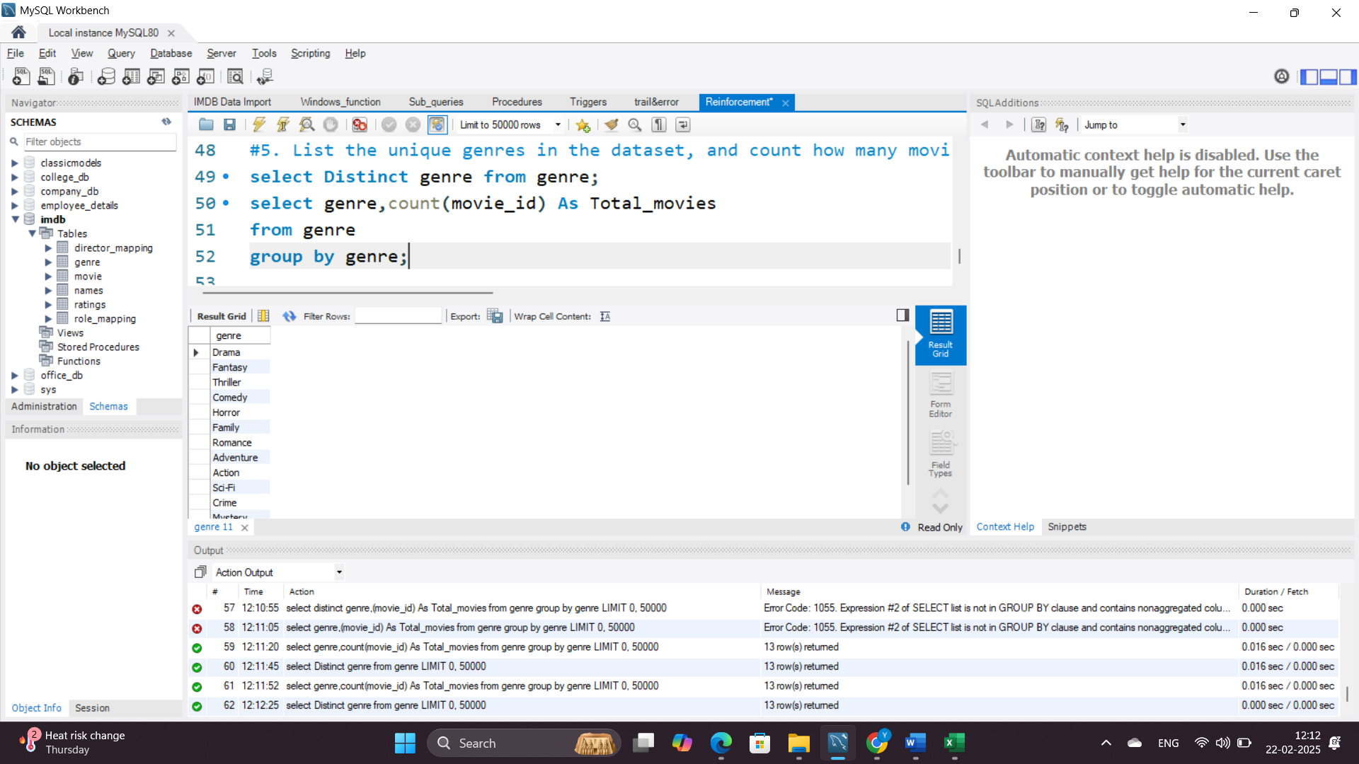

**6. Which genre has the highest total number of movies produced?**

**Query Explanation:** This query counts the number of movies associated with each genre and sorts them in descending order. The LIMIT 1 ensures that only the genre with the highest count is returned.

**Rationale:** Identifies the most popular genre in terms of production count, providing insights into audience preferences and industry trends.

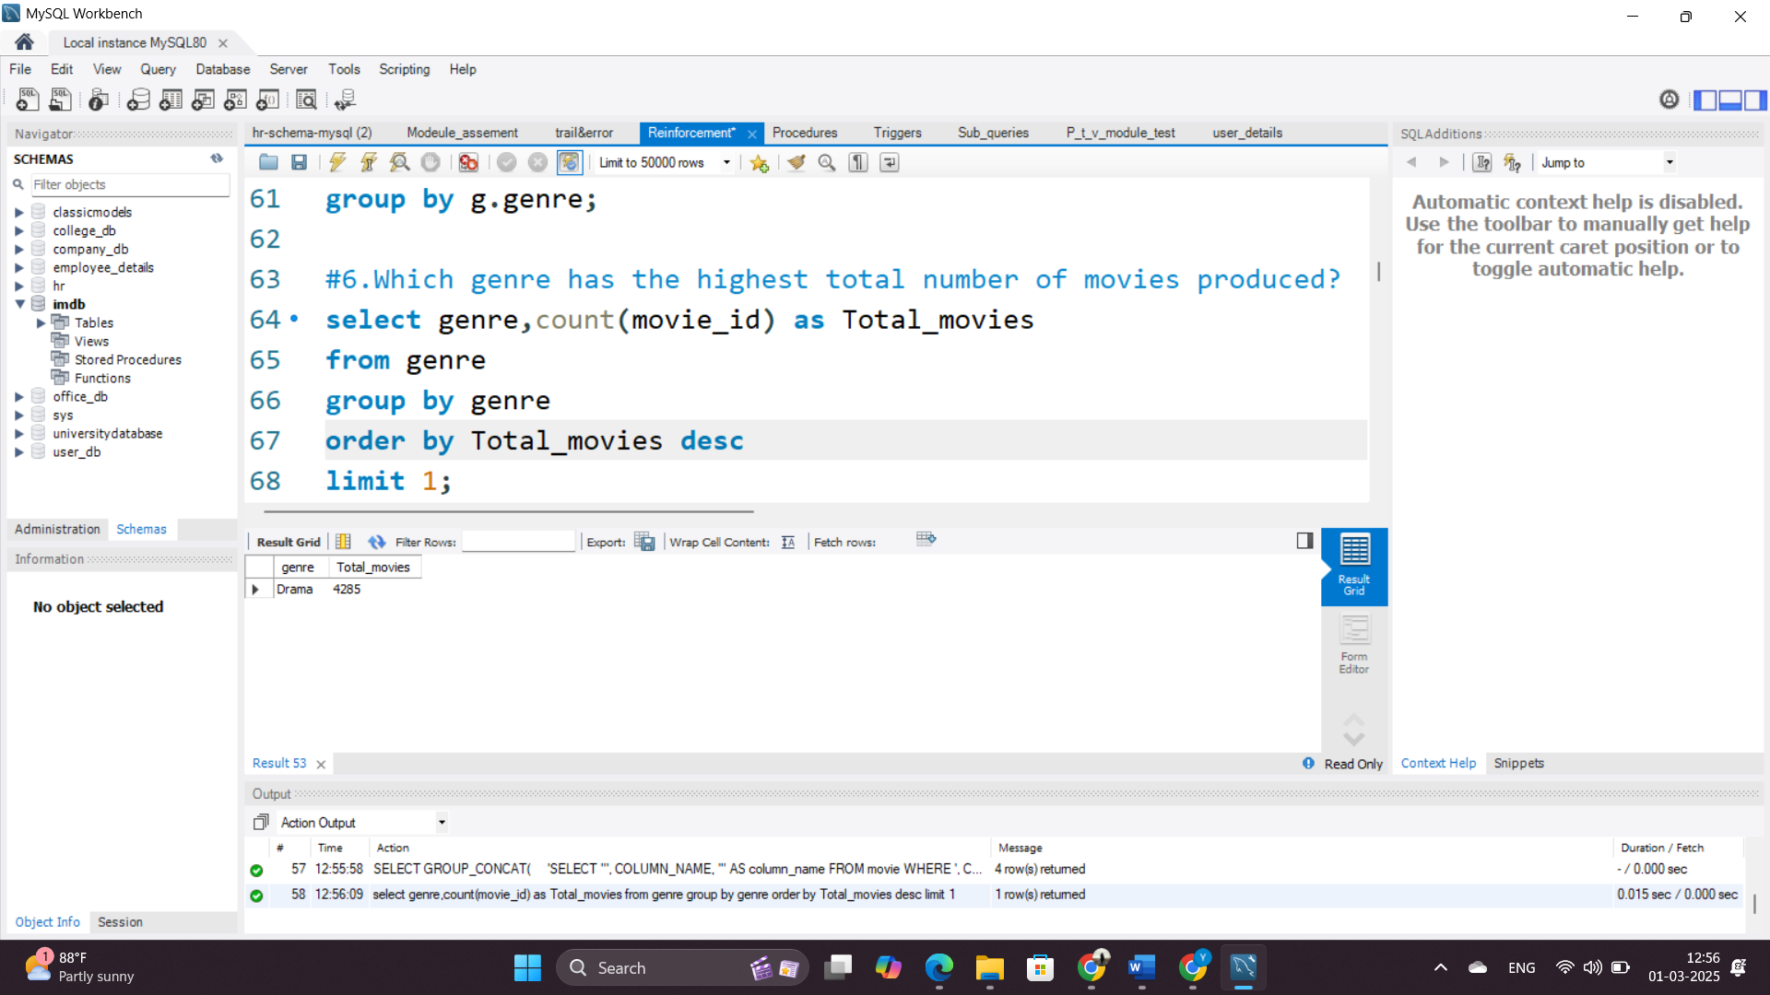

**7. Calculate the average movie duration for each genre.**

**Query Explanation:** The AVG() function computes the mean duration for each genre.

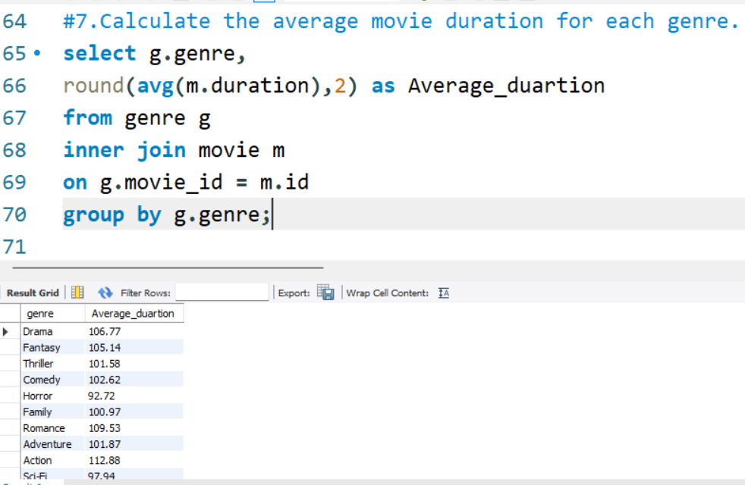**Rationale:** Analyzes typical movie length across different genres.

**8. Identify actors or actresses who have appeared in more than three movies with an average rating below 5.**

**Query Explanation:**

* The INNER JOIN connects role_mapping, ratings, and names tables to retrieve actor names, movie categories, and ratings.
* COUNT(rm.movie_id) counts the number of movies each actor has appeared in.
* AVG(r.avg_rating) calculates the average rating of an actor’s movies.
* The HAVING clause filters actors who have appeared in more than three movies with an average rating below 5.
* The ORDER BY avg_rating sorts the results by average rating in ascending order.

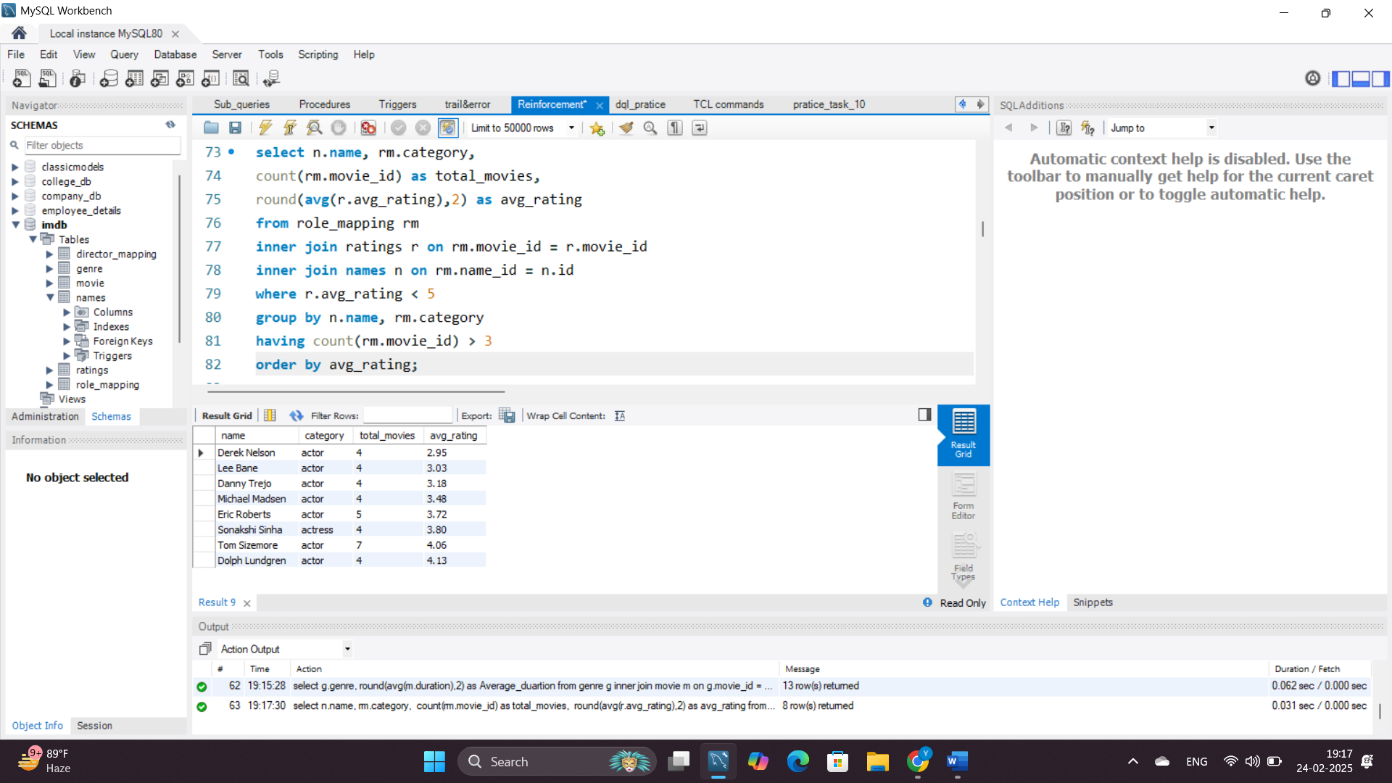**Rationale:** Helps identify actors who have frequently appeared in low-rated movies, which can be useful for performance analysis.

**9. Find the minimum and maximum values for each column in the ratings table, excluding the movie_id column.**

**Query Explanation:** The MIN() and MAX() functions retrieve the lowest and highest values for ratings and votes.

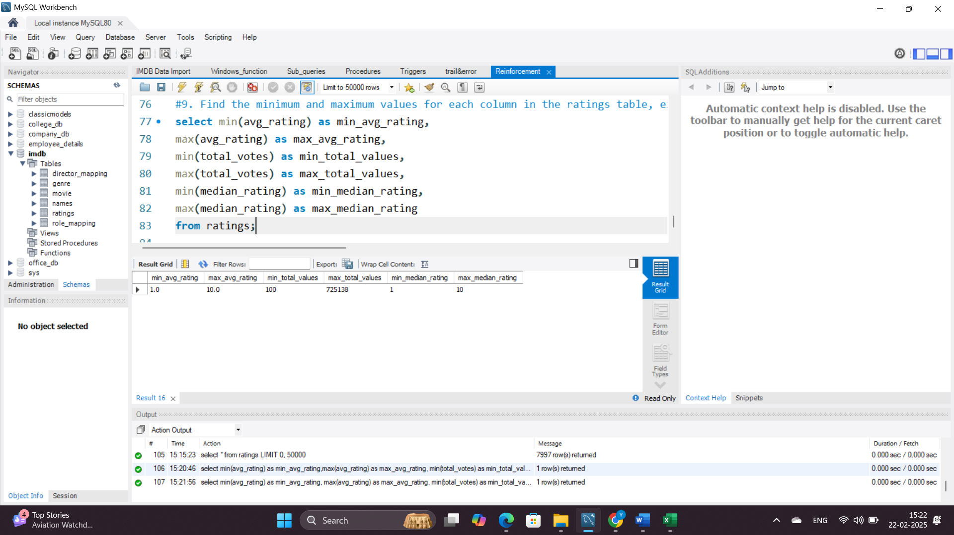**Rationale:** Provides an overview of rating distribution.

**10. Which are the top 10 movies based on their average rating?**

**Query Explanation:**

* The INNER JOIN connects the movie table with the ratings table based on movie_id.
* The ORDER BY avg_rating DESC sorts the movies in descending order based on their average rating.
* The LIMIT 10 ensures that only the top 10 highest-rated movies are returned.

**Rationale:** Identifies the best-rated movies in the dataset, helping to understand audience preferences.

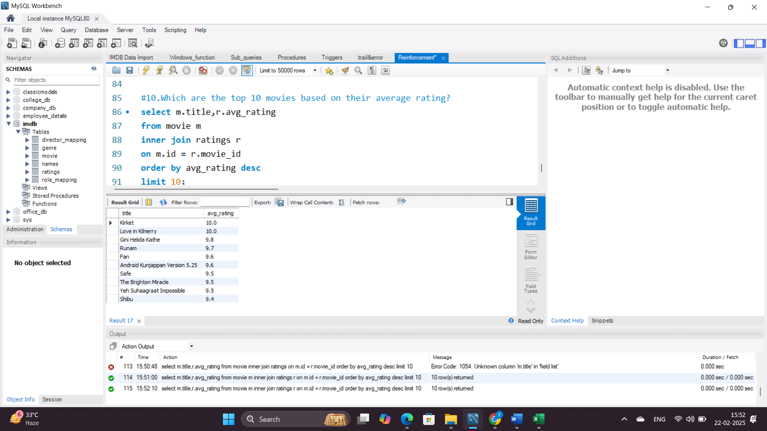

**11. Summarize the ratings table by grouping movies based on their median ratings.**

**Query Explanation:**

* Groups movies by median_rating.
* Calculates total movies, total votes, and average rating.
* Orders results by median_rating.

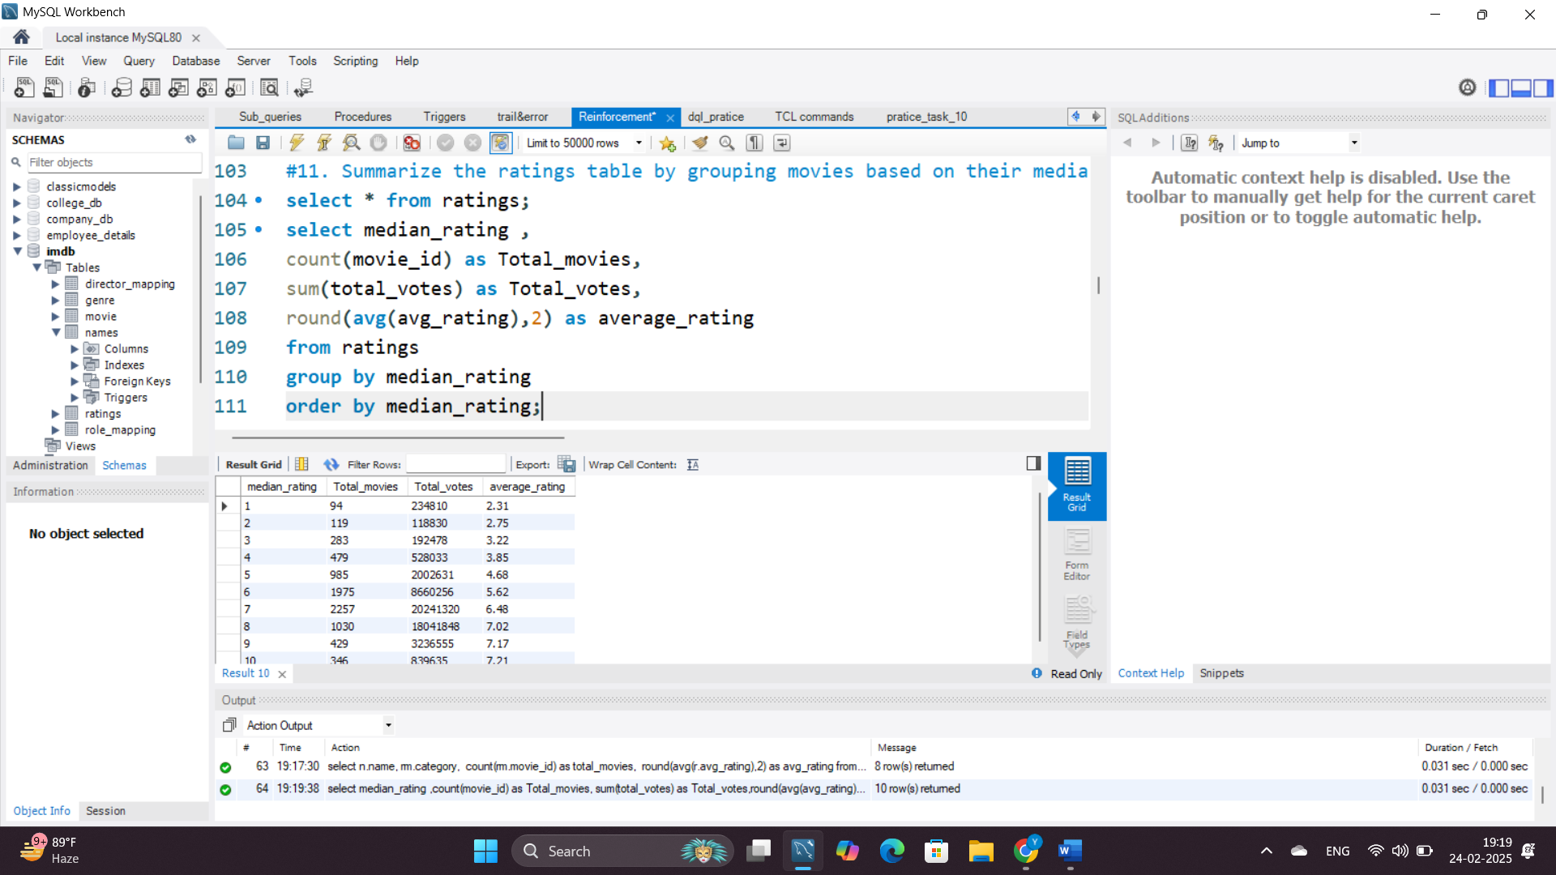**Rationale:** Provides an overview of how movies are distributed across different rating categories.

**12. How many movies, released in March 2017 in the USA within a specific genre, had more than 1,000 votes?**

**Query Explanation:**

* Filters movies released in March 2017 in the USA.
* Joins movie, genre, and ratings tables.
* Counts movies per genre where total votes exceed 1,000.
* Groups results by genre and orders them in descending order.

**Rationale:** Helps analyze the popularity of movies released in a specific timeframe and location.

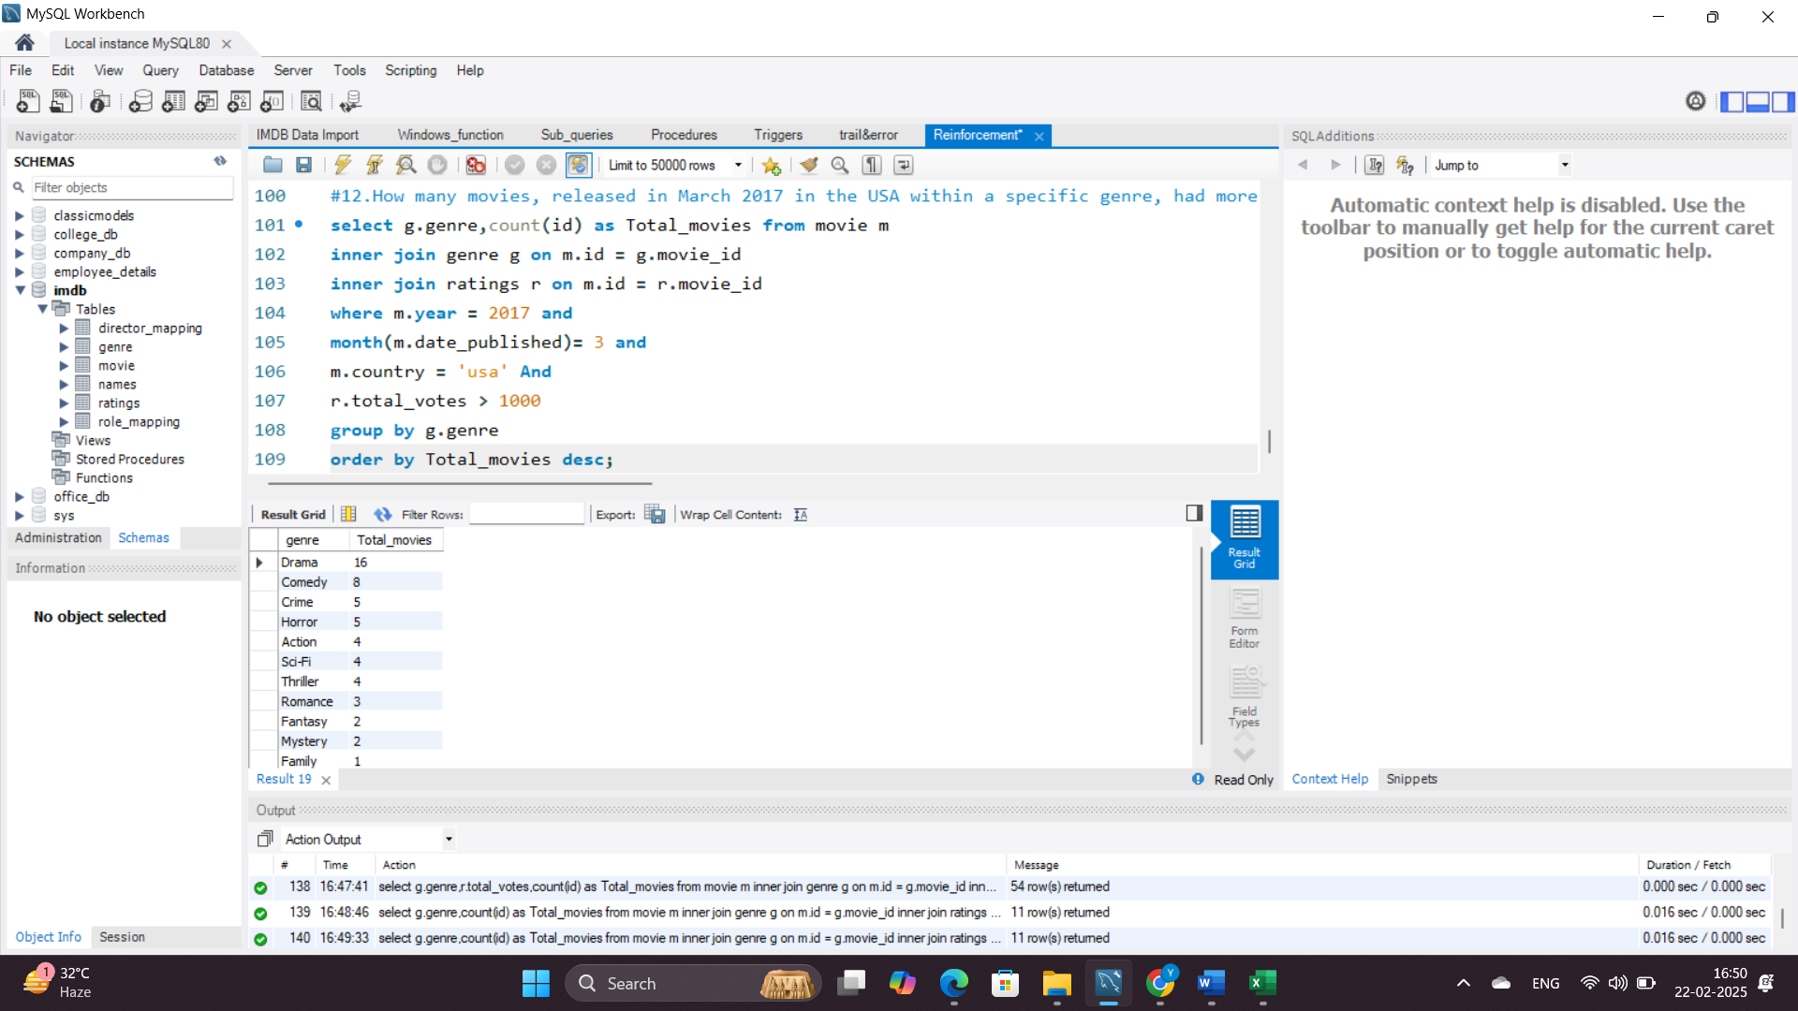

**13. Find movies from each genre that begin with the word “The” and have an average rating greater than 8.**

**Query Explanation:**

* Joins movie, genre, and ratings tables to get movie details.
* Filters movies where the title starts with “The” (LIKE 'The%').
* Only includes movies with an average rating greater than 8.
* Orders results by genre.

**Rationale:** Helps identify highly rated movies that follow a common title pattern.

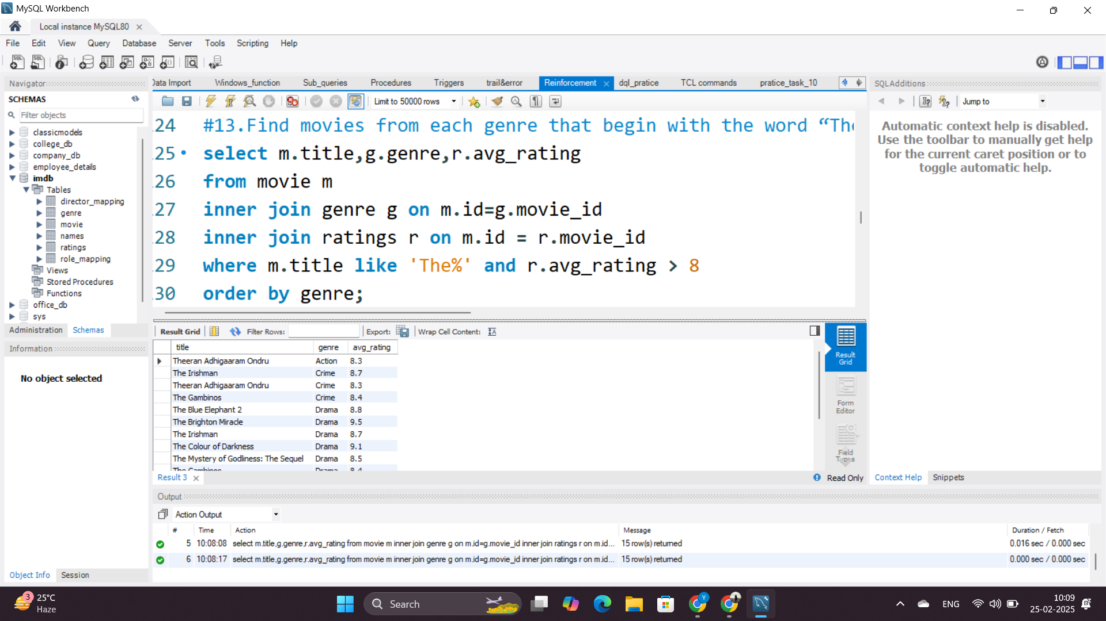

**14. Of the movies released between April 1, 2018, and April 1, 2019, how many received a median rating of 8?**

**Query Explanation:**

* Filters movies released between April 1, 2018, and April 1, 2019.
* Joins movie and ratings tables to get rating details.
* Counts movies where the median rating is exactly 8.

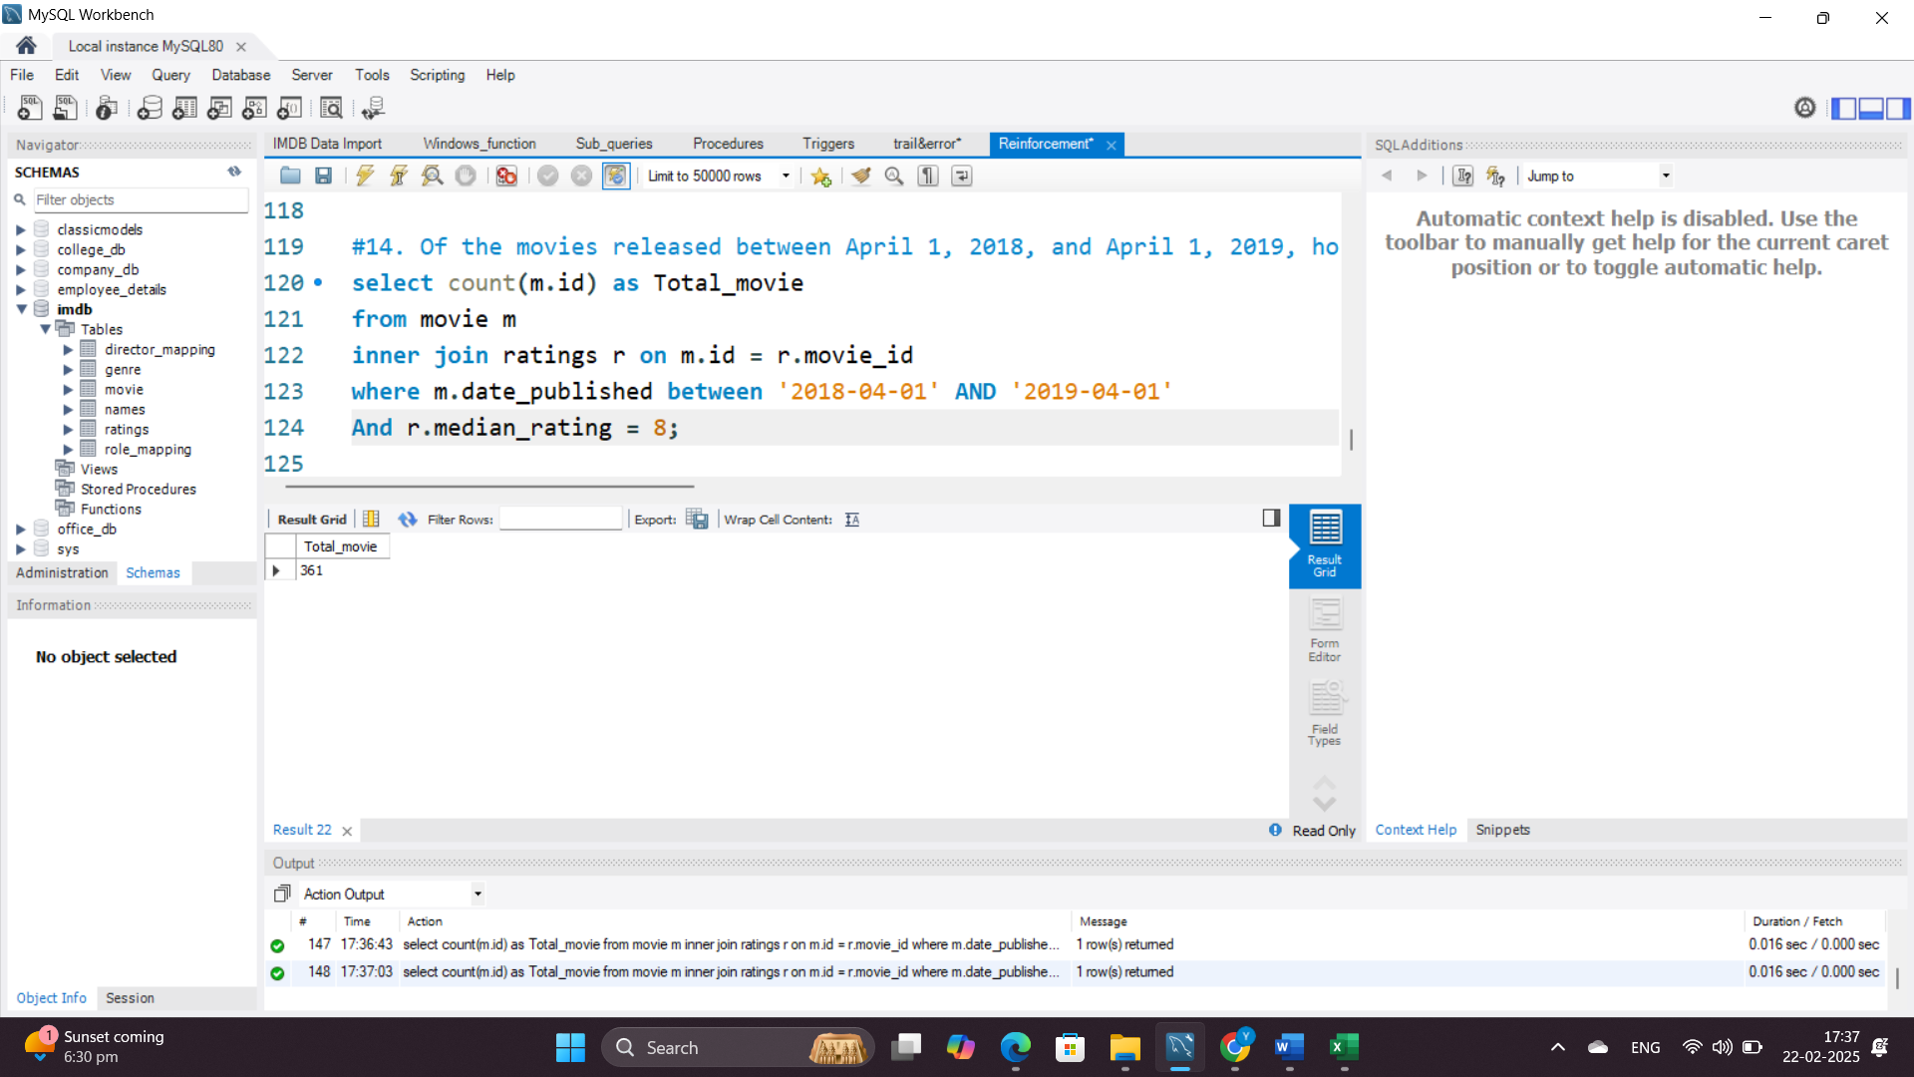**Rationale:** Helps identify well-rated movies within a specific release period.

**15. Do German movies receive more votes on average than Italian movies?**

**Query Explanation:**

* Uses a WITH clause (Common Table Expression) to group movies by language and calculate their average votes.
* The CASE statement classifies languages as either 'German' or 'Italian'.
* The LIKE operator is used in WHERE to filter movies containing 'German' or 'Italian' in their language field.
* The main query compares the average votes between the two languages.
* Determines which language has higher engagement based on votes.

**Why WITH?** It simplifies complex queries by creating a temporary named result set that can be referenced multiple times within the query.

**Why CASE?** It ensures all language variations (e.g., 'German, English') are categorized correctly.

**Why LIKE in WHERE?** It allows filtering movies that have multiple languages listed but still contain 'German' or 'Italian'.

**Rationale:** Helps compare audience engagement for movies in different languages.

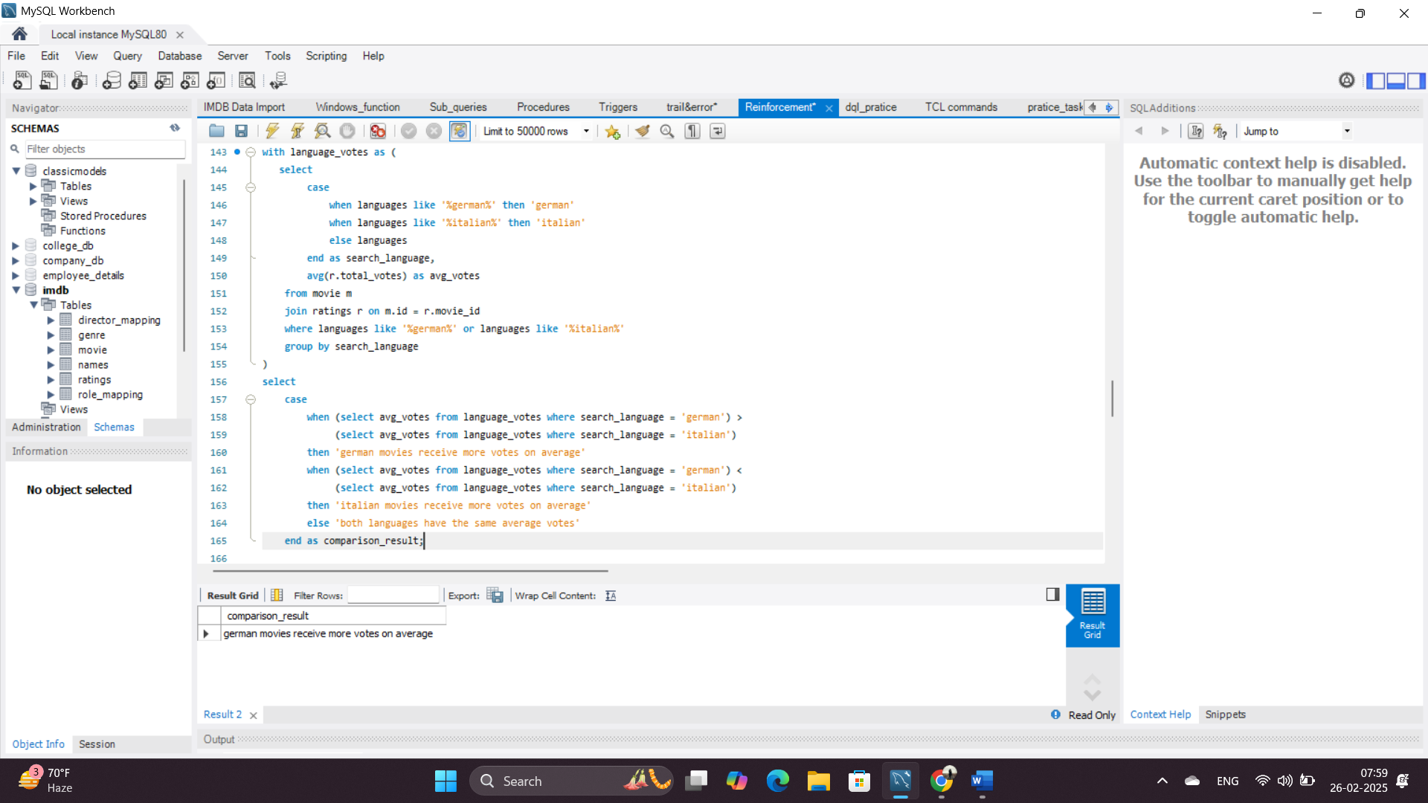

**16. Identify the columns in the names table that contain null values.**

**Query Explanation:**

* Uses INFORMATION_SCHEMA.COLUMNS to get all column names from the names table.
* Constructs a dynamic SQL query using GROUP_CONCAT to check each column for NULL values.
* Stores the generated query in @sql, then executes it using PREPARE and EXECUTE.
* DEALLOCATE PREPARE cleans up the prepared statement.

**Why INFORMATION_SCHEMA.COLUMNS?** It helps dynamically retrieve all column names, making the query adaptable if new columns are added.

**Why GROUP_CONCAT?** It combines multiple SELECT statements into a single query to check NULL values for all columns at once.

**Rationale:** Automates the detection of NULL values in all columns without manually checking each one.

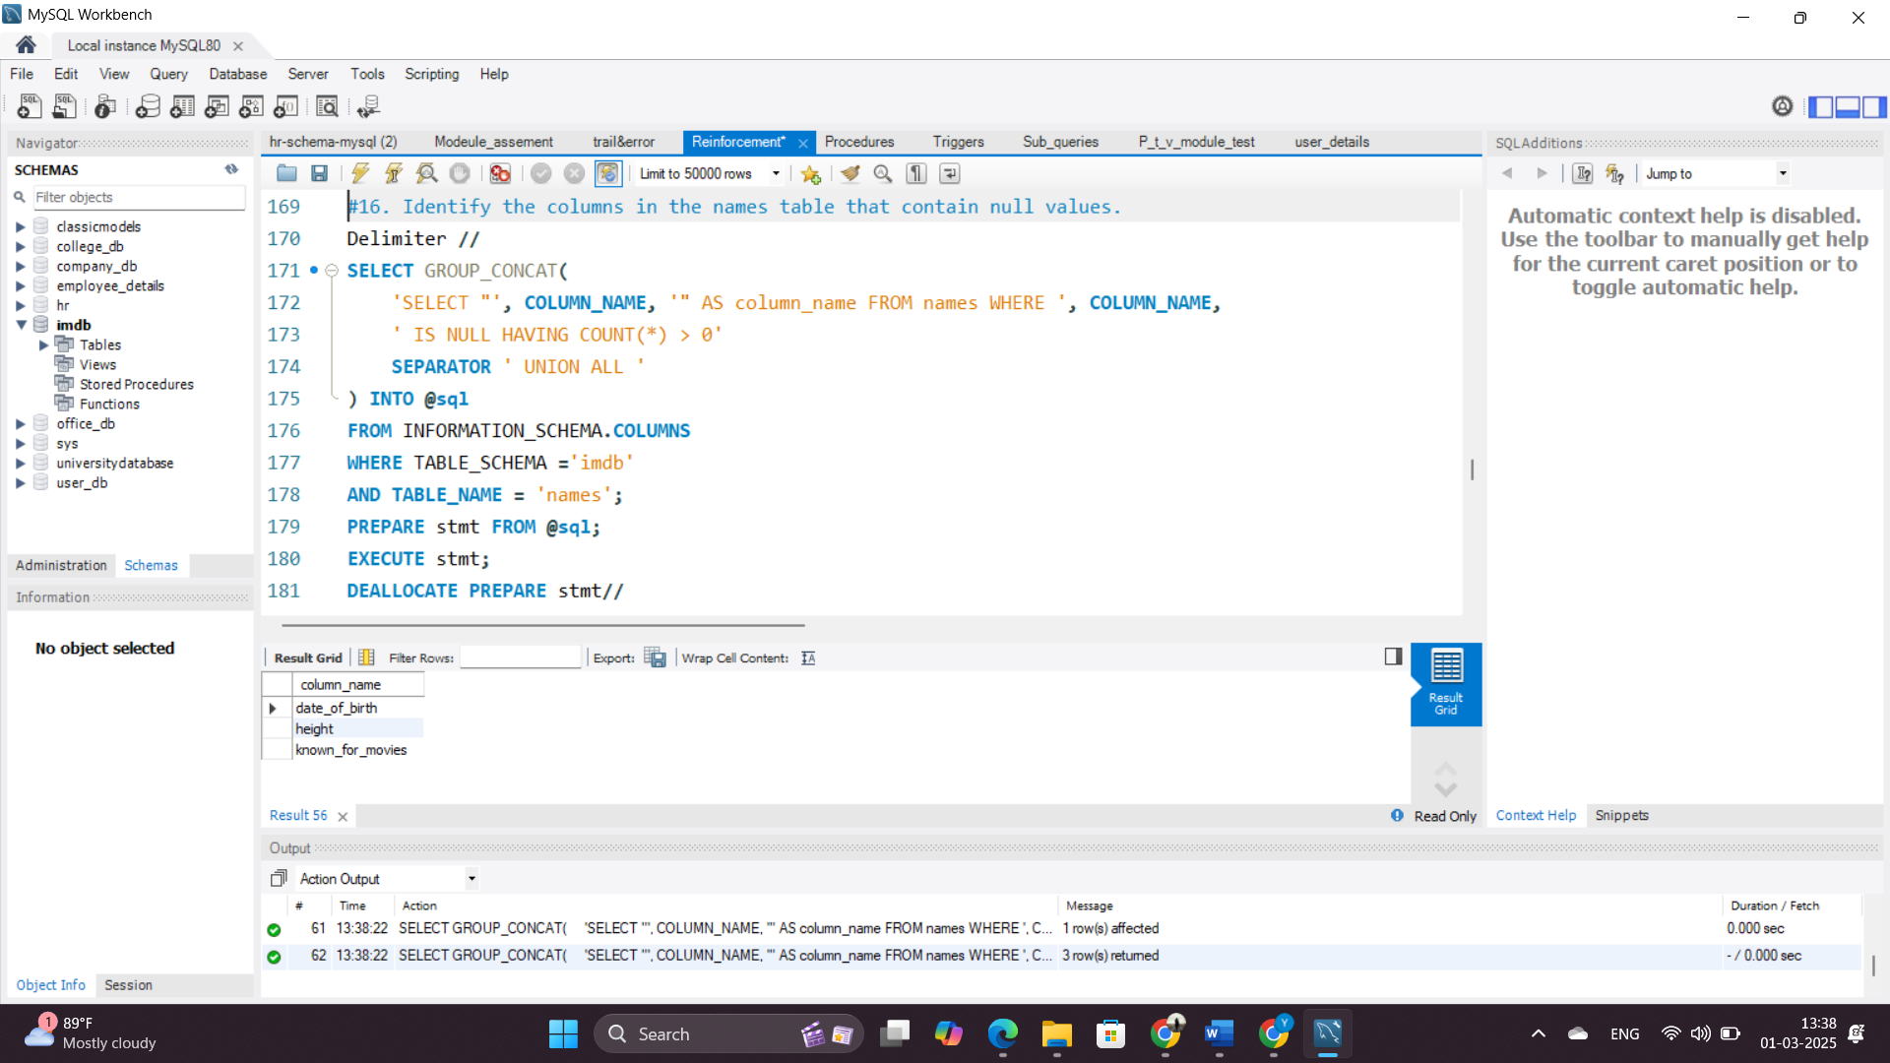

**17. Who are the top two actors whose movies have a median rating of 8 or higher?**

**Query Explanation:**

* Joins names, role_mapping, and ratings tables to get actor details and ratings.
* Filters only actors (rm.category = 'actor') whose movies have a median rating of 8 or higher.
* COUNT(r.movie_id) counts the number of qualifying movies per actor.
* ORDER BY count_of_movies DESC ensures the actors with the most highly-rated movies appear first.
* LIMIT 2 selects only the top two actors.

**Rationale:** Identifies actors associated with the highest number of well-rated movies.

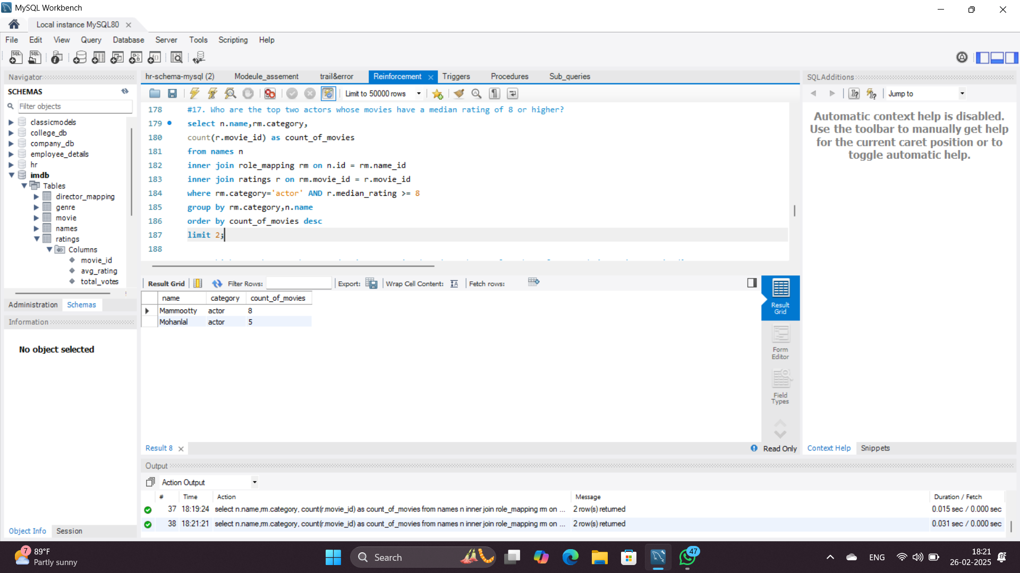

**18. Which are the top three production companies based on the total number of votes their movies received?**

**Query Explanation:**

* Joins production companies with movie ratings.
* Aggregates votes for each company.
* Sorts and selects the top three.

**Rationale:** Identifies companies with the highest audience engagement.

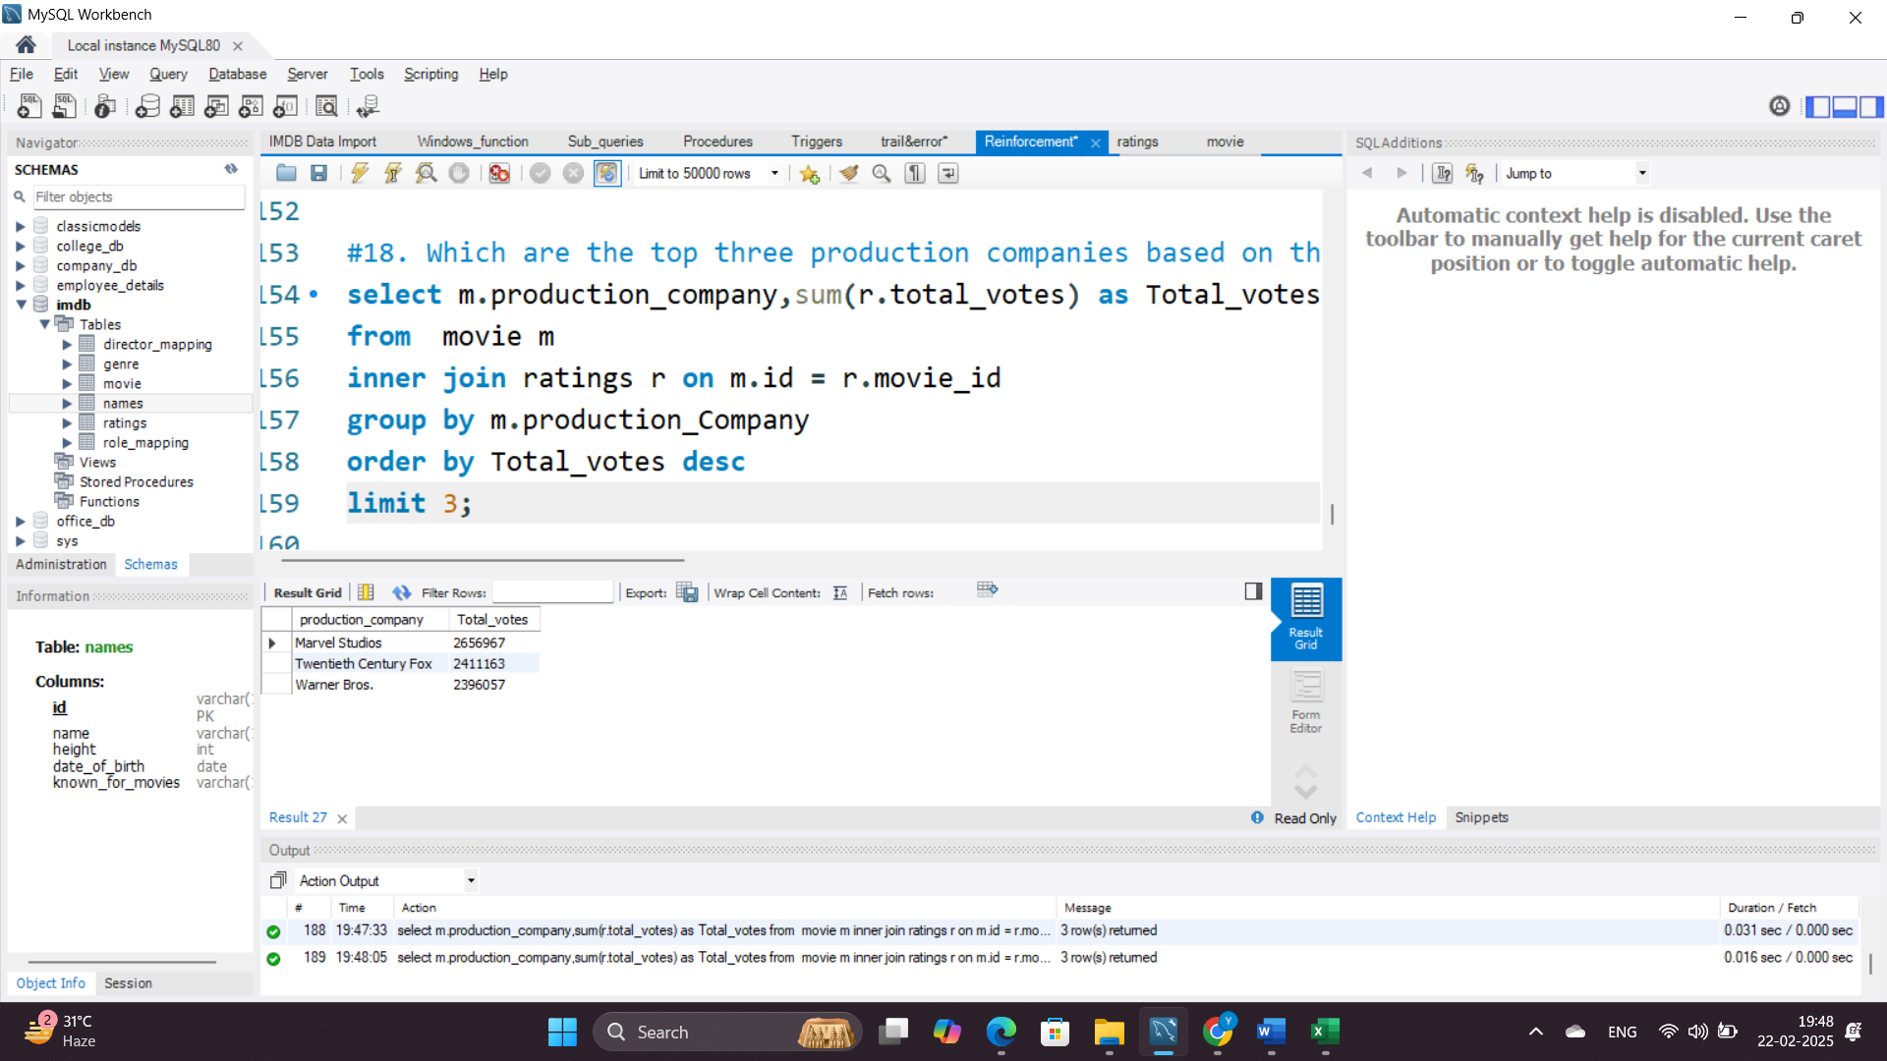

**19. How many directors have worked on more than three movies?**

**Query Explanation:**

* Joins names and director_mapping tables to find director-movie relationships.
* Groups by director name and filters those with more than three movies.
* Uses a subquery to count and return the number of such directors.

**Rationale:** Identifies experienced directors who have worked on multiple projects

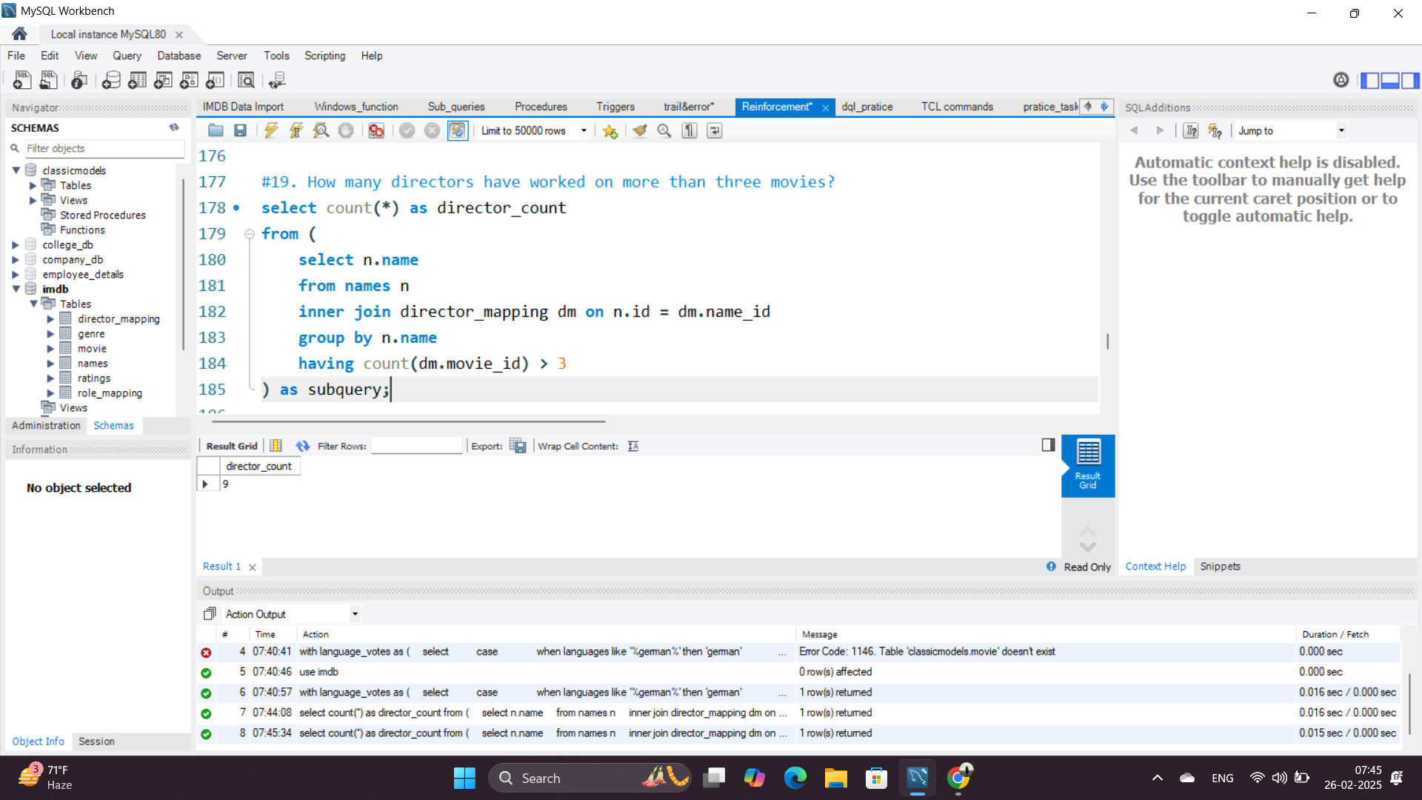

**20. Calculate the average height of actors and actresses separately.**

**Query Explanation:**

* Joins names and role_mapping tables to retrieve height data for actors and actresses.
* Uses AVG(n.height) to calculate the average height for each category.
* Groups results by category (actor/actress).

**Rationale:** Helps analyze physical attributes of movie cast members separately by gender.

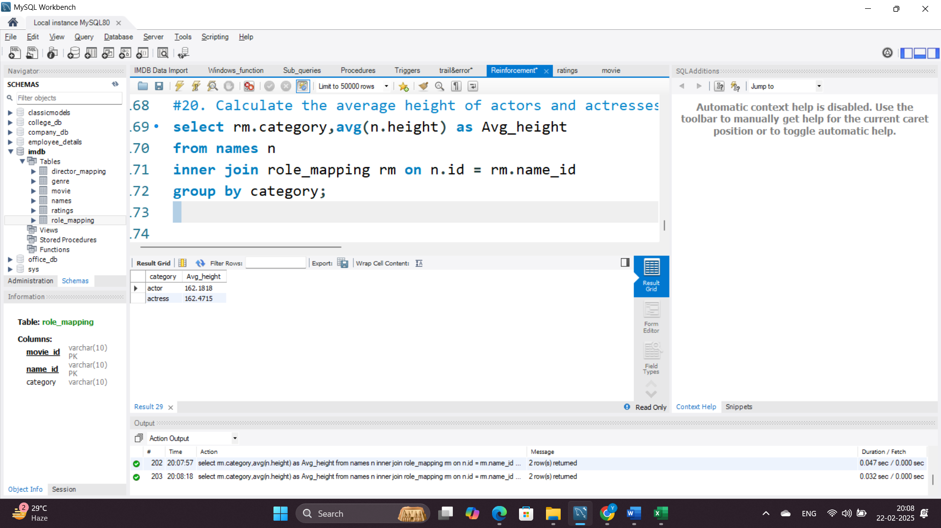

**21. List the 10 oldest movies in the dataset along with their title, country, and director.**

**Query Explanation:**

* Joins movie, director_mapping, and names tables to get movie and director details.
* Orders movies by date_published in ascending order.
* Limits results to the 10 oldest movies.

**Rationale:** Identifies the earliest movies in the dataset.

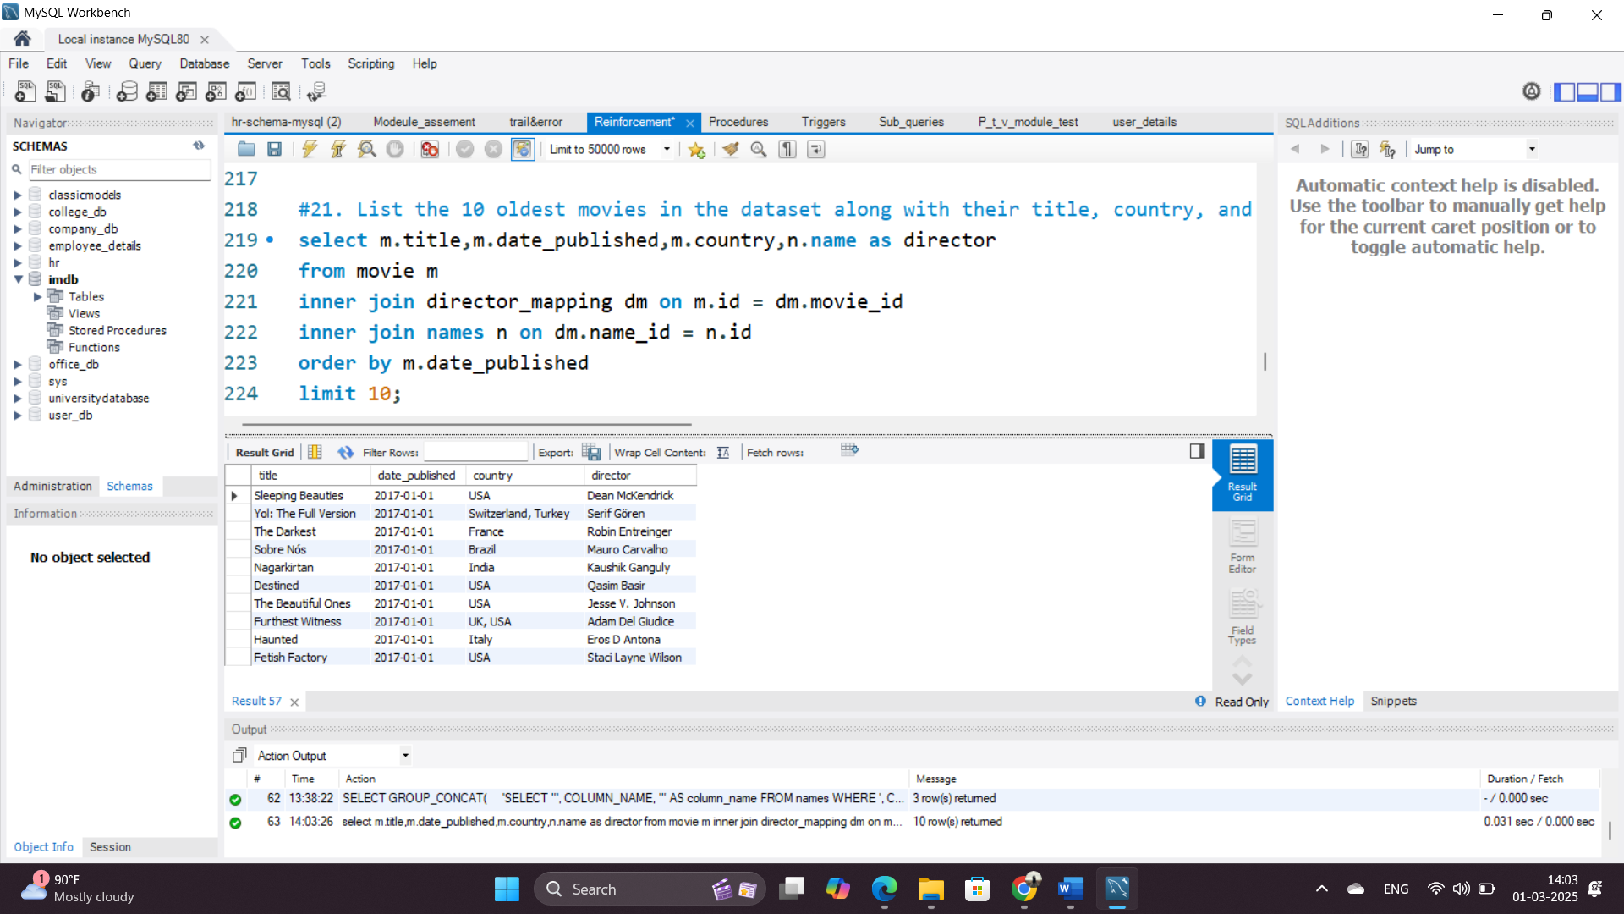

**22. List the top 5 movies with the highest total votes, along with their genres.**

**Query Explanation:**

* Joins movie, genre, and ratings tables.
* Uses GROUP_CONCAT to list multiple genres per movie.
* Sorts by total votes in descending order.
* Limits results to the top 5.

**Rationale:** Identifies the most popular movies based on audience votes.

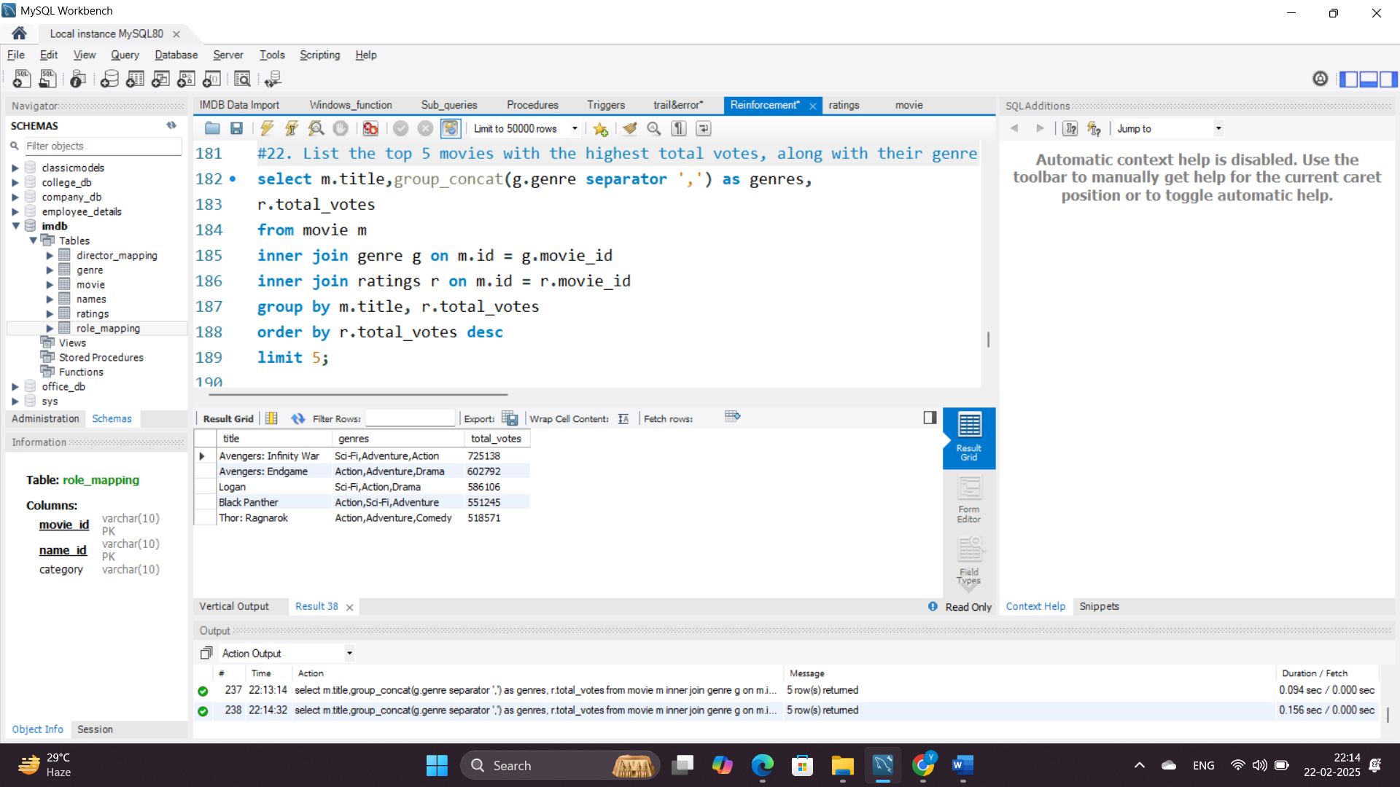

**23. Identify the movie with the longest duration, along with its genre and production company.**

**Query Explanation:**

* Joins movie and genre tables to get genre details.
* Filters the movie with the maximum duration.
* Uses GROUP_CONCAT to list multiple genres for the movie.

**Rationale:** Finds the longest movie and its associated details.

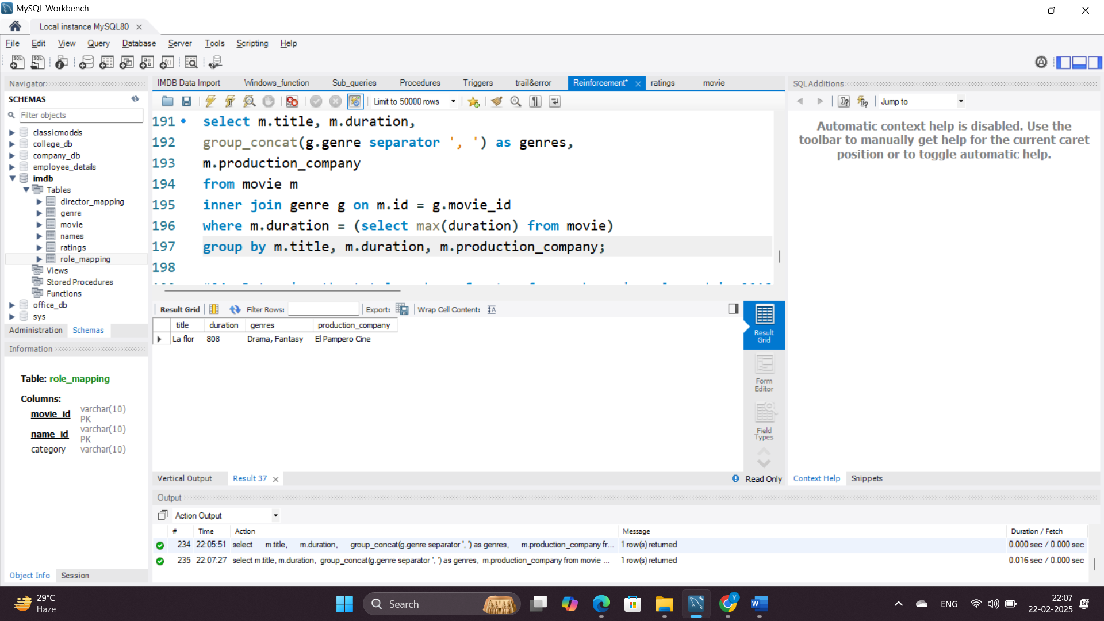

**24. Determine the total number of votes for each movie released in 2018.**

**Query Explanation:**

* Joins movie and ratings tables.
* Filters movies released in 2018.
* Sums total votes per movie and sorts in descending order.

**Rationale:** Identifies the most voted movies from 2018.

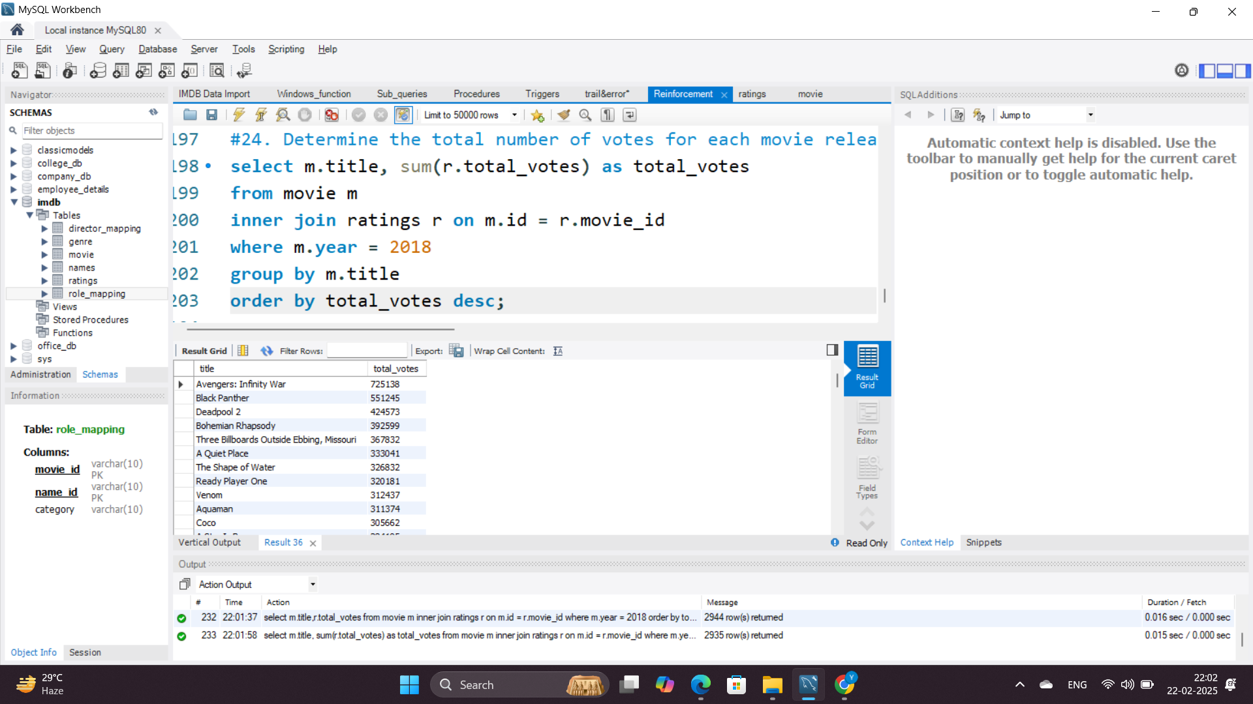

**25. What is the most common language in which movies were produced?**

**Query Explanation:**

* Groups movies by language and counts the number of movies in each.
* Orders results by movie count in descending order.
* Limits output to the most common language.

**Rationale:** Identifies the dominant language in movie production.

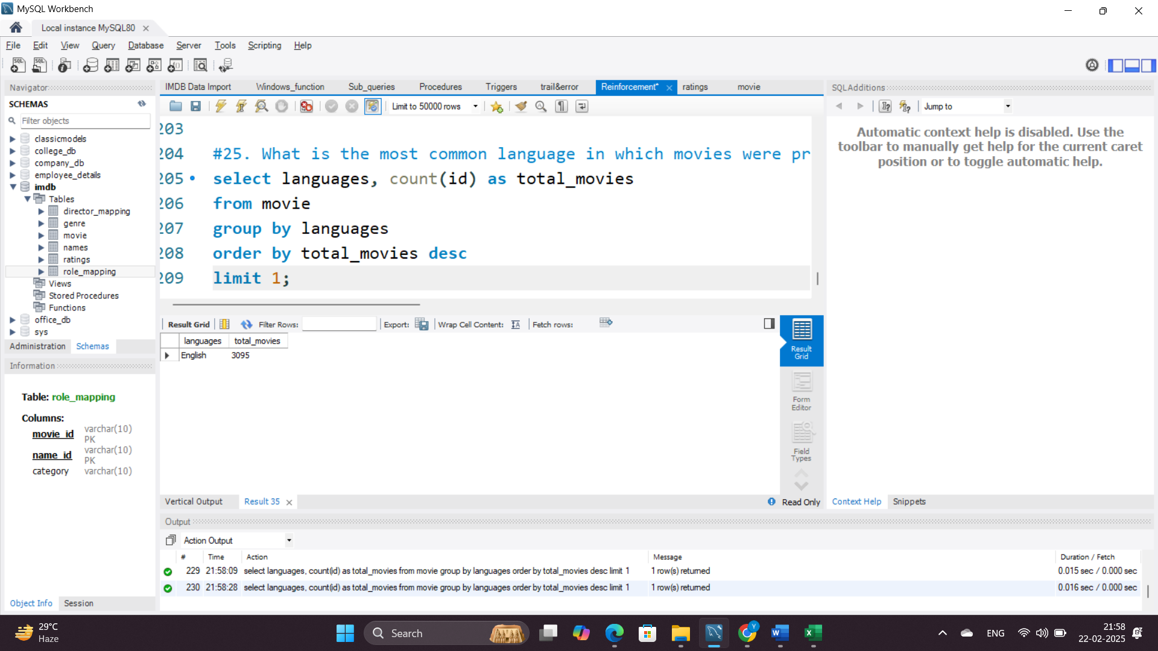

**Date :** 03-03-2025

**By,**

**Yahavarshini E**